Mandiant Join Implementation
WTCA-H-01 – Implementation Recommendation

In order to allow for logins and account creation to fill out new membership applications, we will implement the following workflow below:

Account Creation

1. The Account Creation process is triggered when a user fills out an Expression of Interest Form (EOIF).
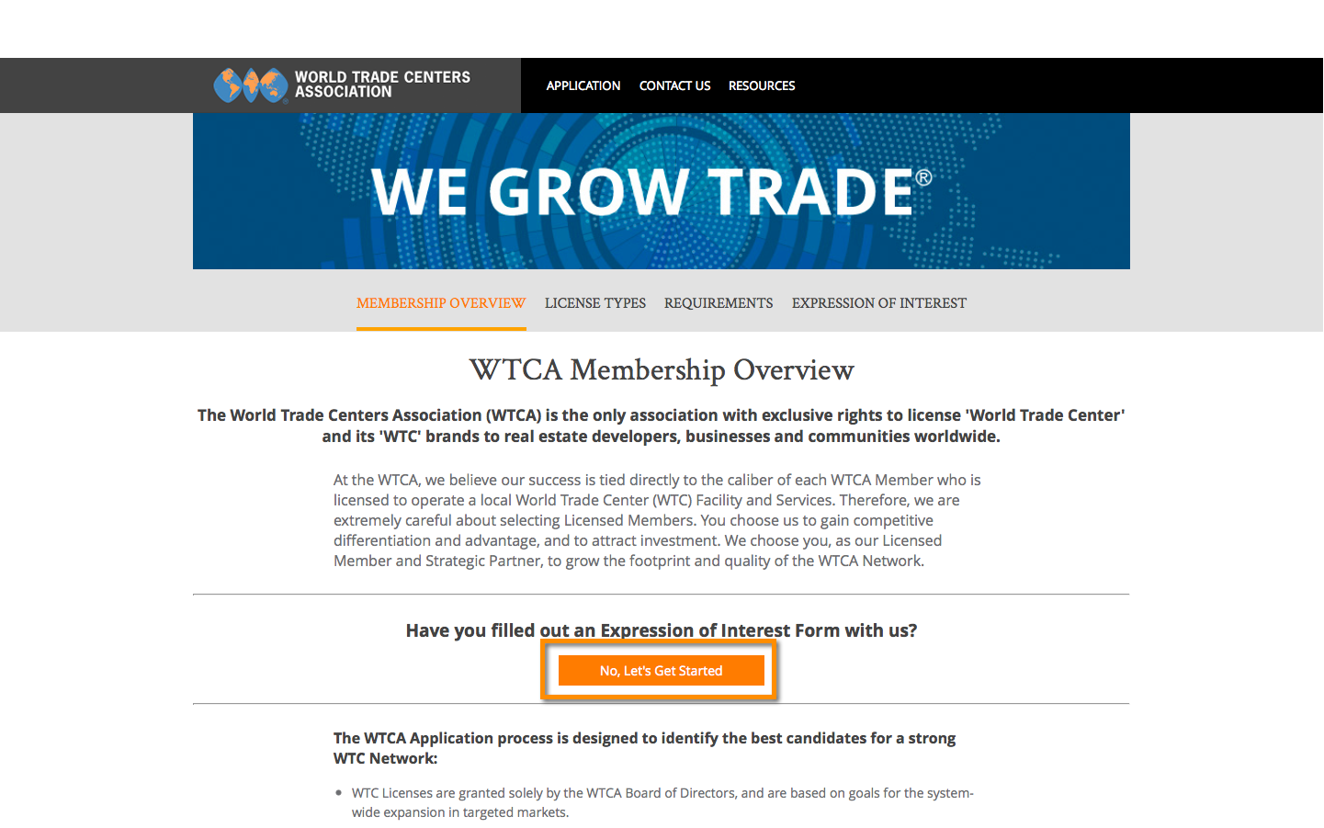

2. Once an EOIF has been submitted, it appears in the Admin dashboard, with a status of In HQ Review. Click View
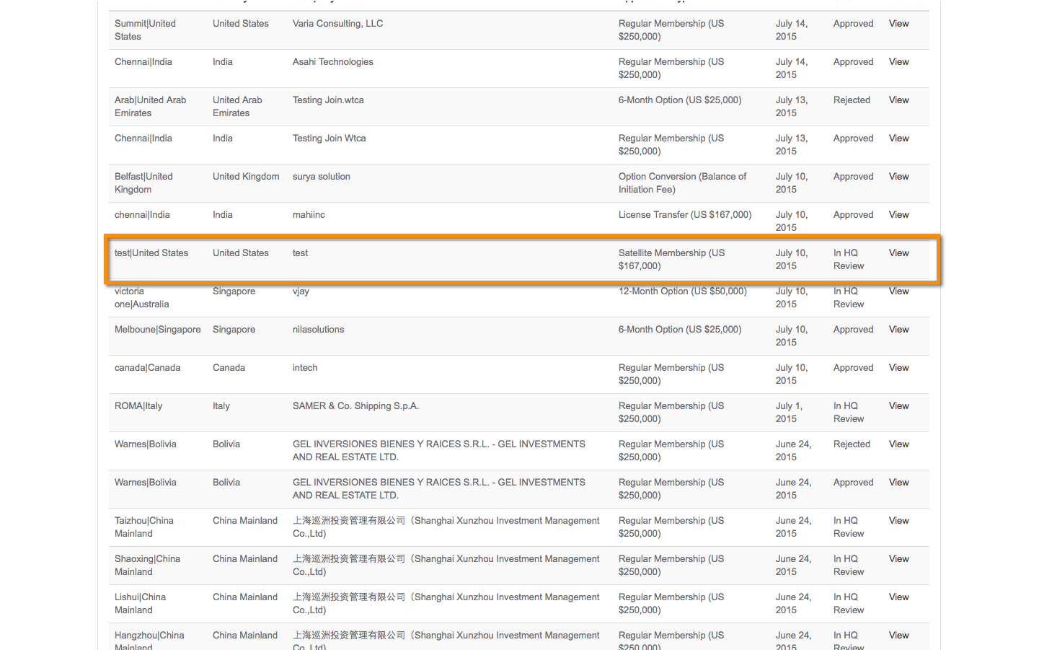

3. Once approved, the Admin will click Review Complete, and then EOIF Accepted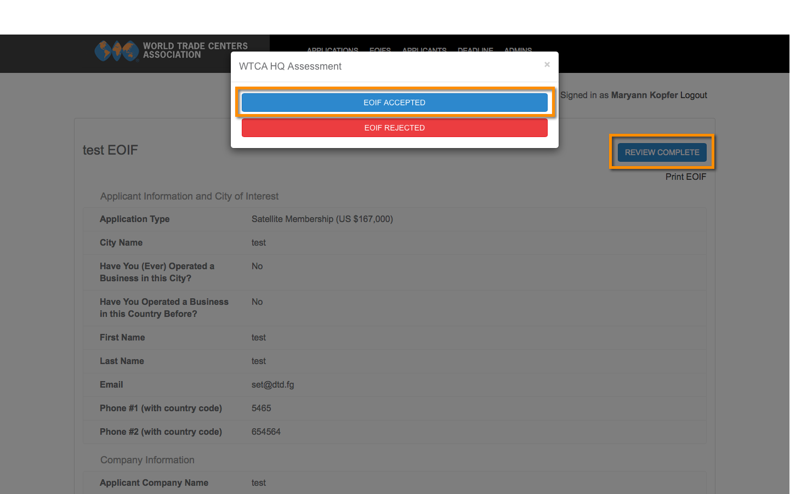

4. Once approved, an automated email is generated. This email will contain a link to allow the applicant to set a password for their account. The new account will be created using their system generated Account Key as the user name.

In the future, users will be able to continue to use the link provided in this email to access their application. They will just be prompted to provide the password they set initially.

The URL should be structured with a unique login URL, passing the encrypted account key. The first time the URL is used, a user needs to set a password. When the URL is used again going forward, they are just prompted to provide their password to sign in.

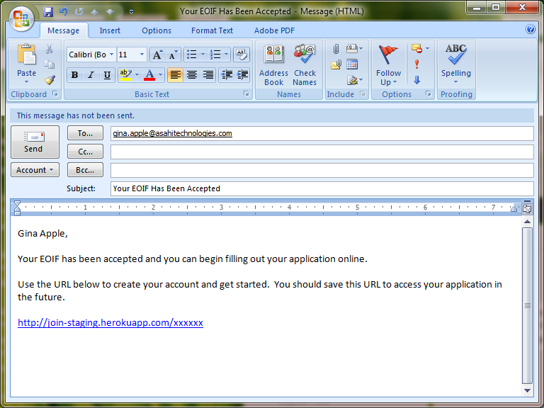

5.1. The applicant is prompted to create their password the first time the URL is used:

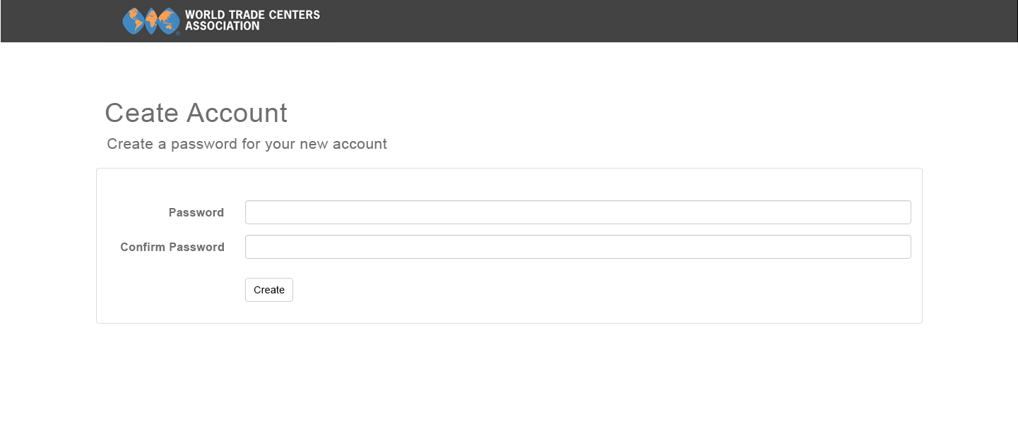

5.2. When the applicant clicks the link subsequent times, the log in screen appears, prompting for the password:

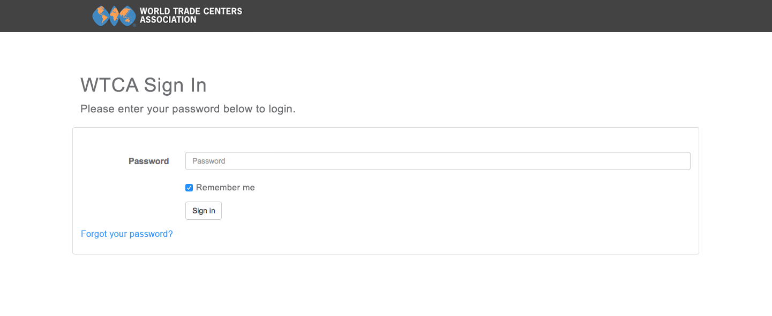

Clicking the Forgot your password link will automatically trigger an email to the applicant with a link to reset their password (as portrayed in item 11). There is no need to enter an email address first, as we already identify the user based on their Account Key.

6. Once the password is set and the account is finalized, the user will be redirected to an Applicant Dashboard. This is a modified version of the landing page, previously available at the Unique URL. This page will also appear as the landing page for all applicants upon sign-in.

The main changes on this page include:
- sign-out button
- link to edit profile
- Unique ID will be removed

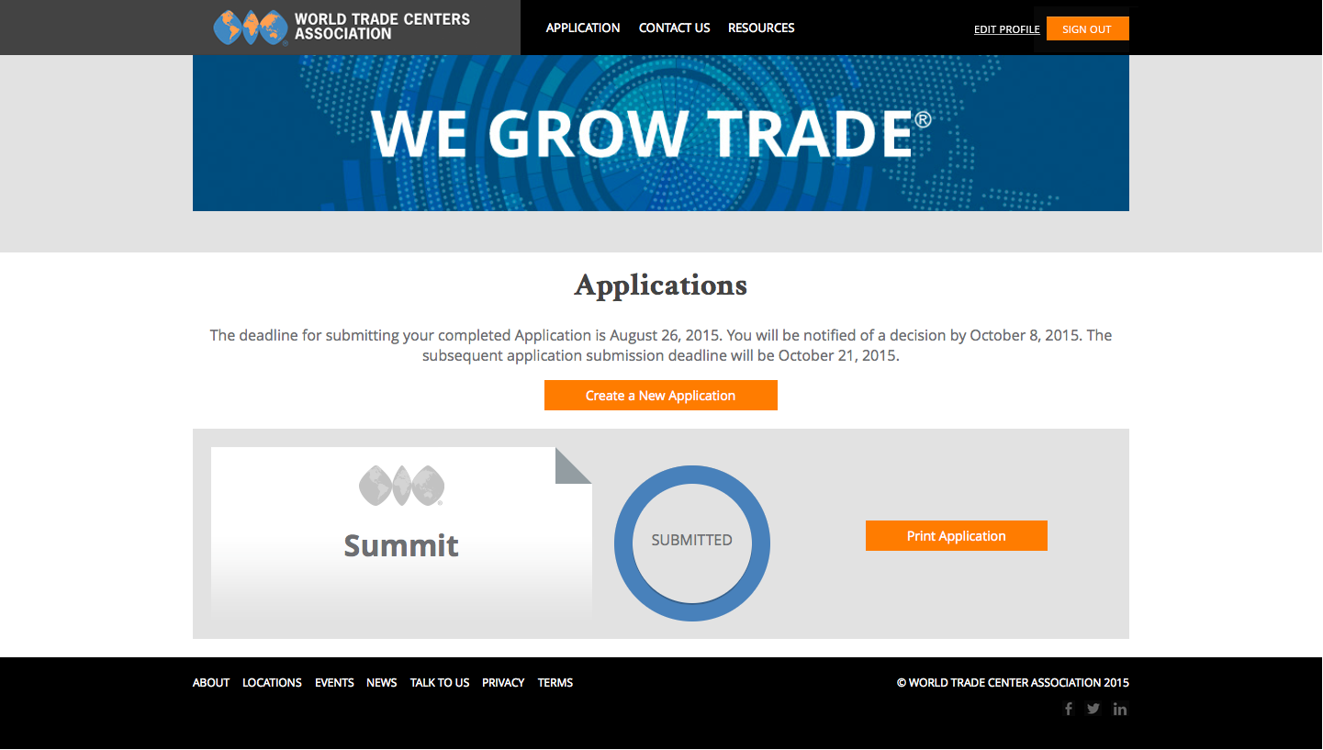

6.1. When clicking the Edit Profile link, we bring up a modal, similar to the one that currently exists when editing an Admin account. The only difference is the language, and the option for user type is removed.

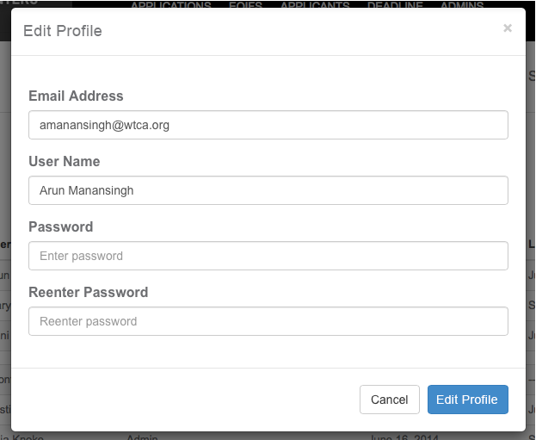

Additional Application Changes

7. All users will only be stored in the Applicants page, as they are now. We previously discussed managing this list of users along with the admins, but now I feel they should stay on the Applicants page only.

We will maintain the Unique URL.

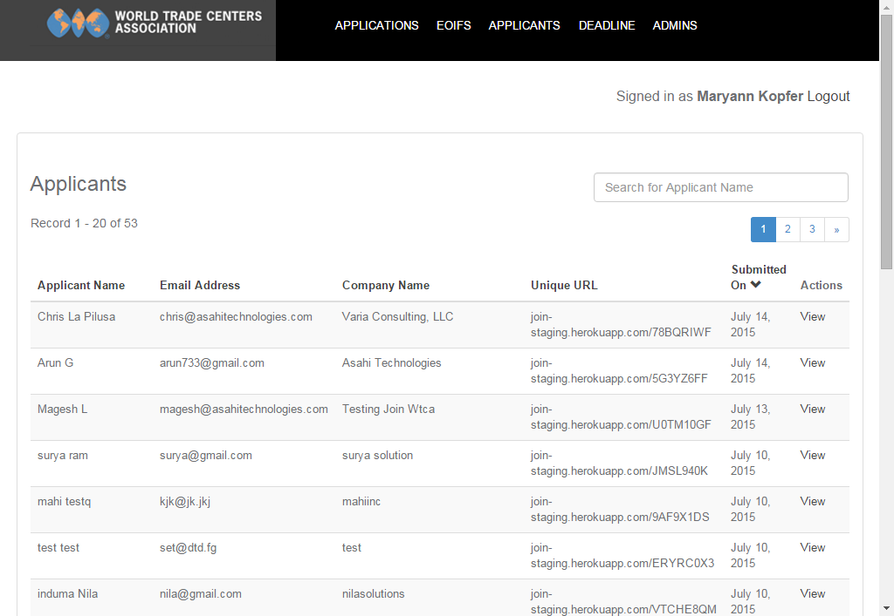

7.1. When clicking the View link, we modify the page by adding an Edit Profile button. Clicking Edit Profile brings up the same Modal as outlined in section 6.1.

The Unique URL will remain.

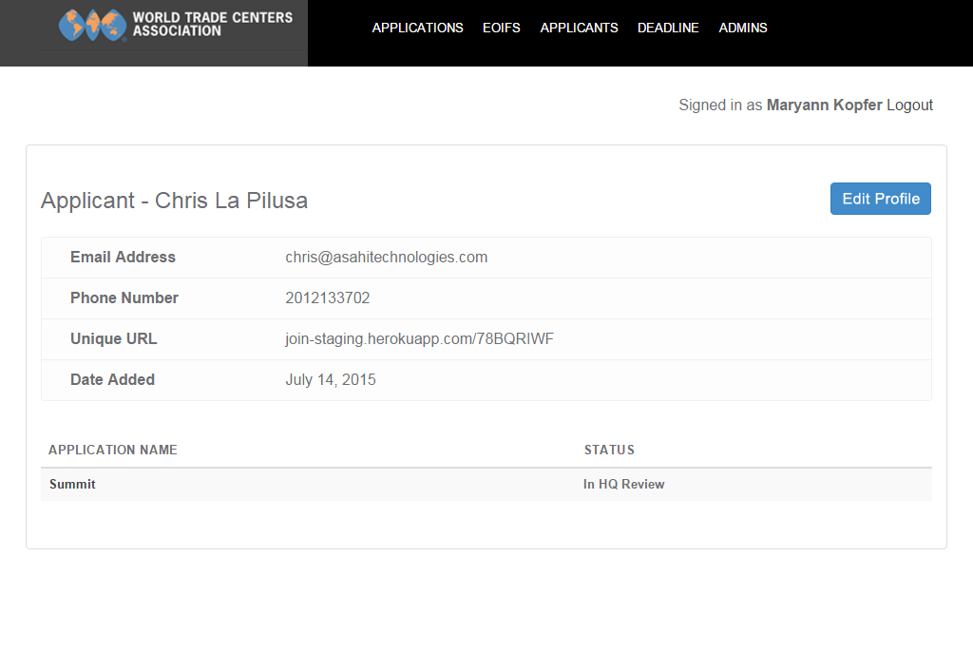

8. A login button will be added to the Join homepage. This will be used for Admins to log in only.



9. The login page will be modified as depicted below:

- The title of the page changes from WTCA – Admin to WTCA Sign In
- The Keep me signed in label changes to Remember me
- Include a new hyperlink for Forgot your password? When clicking this link, we proceed to item 10.

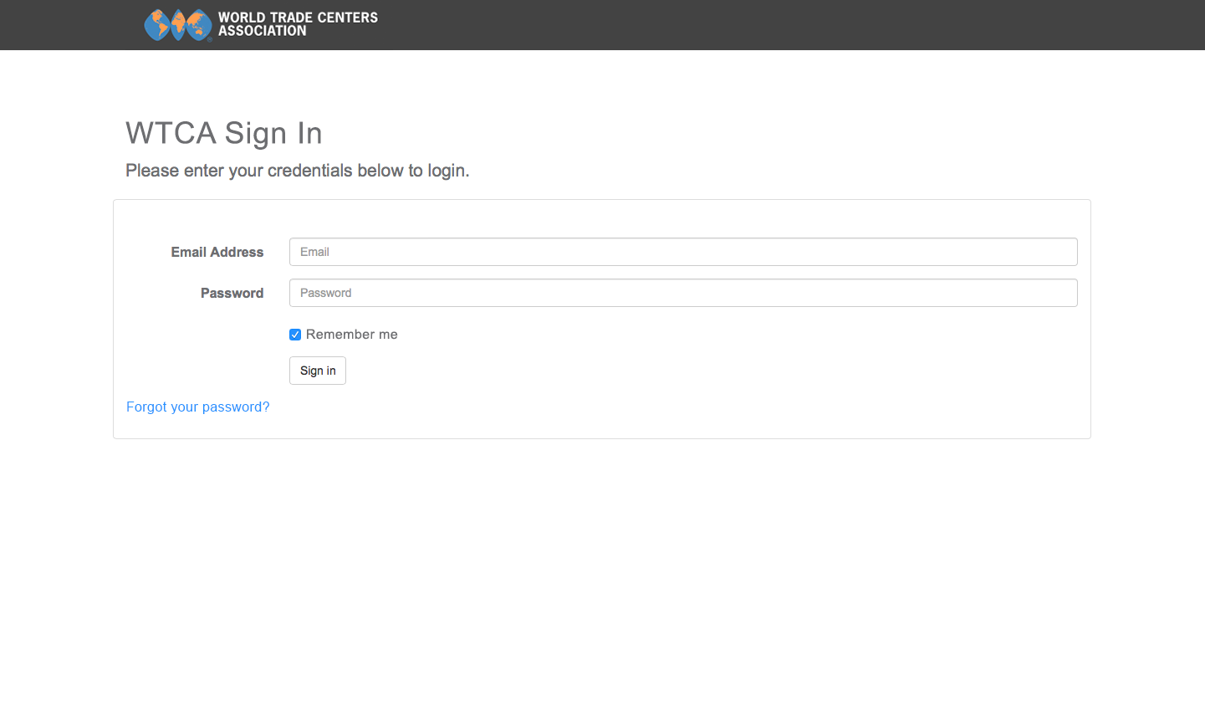

10. We will be adding a Forgot Password feature, as visually designed below. The email address should not be case sensitive.

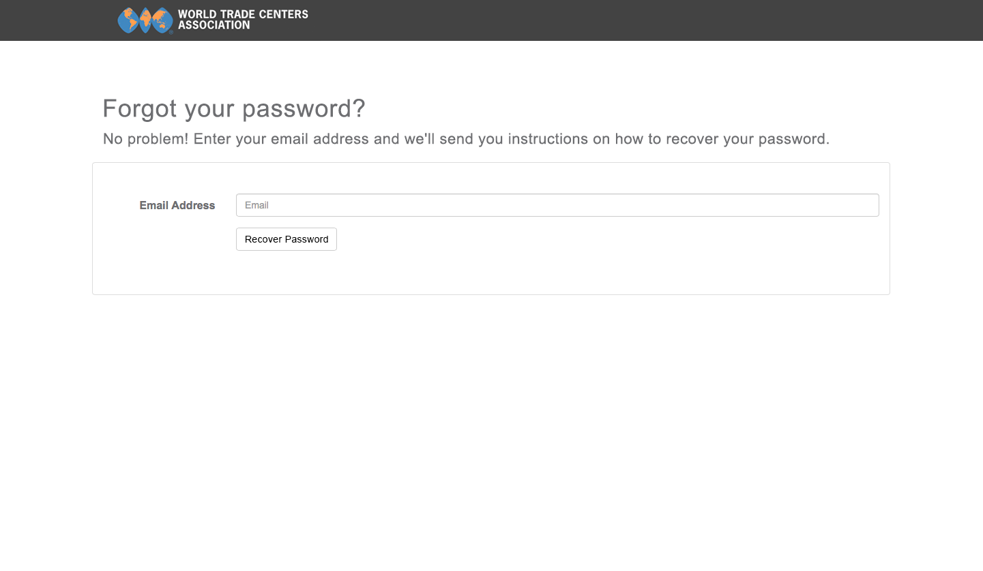

11. The text for the Recover Password email should be as follows:

From: World Trade Centers Association (no-reply@wtca.org)
Subject: WTCA Password Reset Request

This e-mail is in response to your recent request to recover a forgotten password. Click here to reset your password.

If you believe you are the subject of suspicious activity, please contact help@wtca.org.

Thank you,

WTCA Support

If you are having trouble accessing the link, copy and paste the following link address into your browser window:

[full url]

If after copying and pasting the link address above into your browser window, you are still having trouble accessing the link, try typing the link address into your browser window

Please do not reply to this e-mail.

Clicking on the link provided in the email directs the user to item 11.1.

11.1 . Set New Password Screen

